

Customer Advance Ship Notice

(ASN)

Technical Implementation Guide

# Table of Contents

Table of Contents 2

Document control 3

Purpose 3

Overview 3

Format 4

Schema 4

Example 4

Data elements used 4

High level structure 4

Header 5

Item list 7

Container list 9

ASN summary 11

Data File Delivery 11

Email notice 12

Shipping Labels 13

Parcel Carrier 14

LTL 15

Product Barcodes 16

# Document control

|  |  |  |
| --- | --- | --- |
| Version | Date | Description |
| 1 | 2019/09/06 | Approved |
| 2 | 2019/09/13 | Added Shipping Label reference and TOC |
| 2.1 | 2019/09/25 | Added Tracking Number mapping destails to Container List section.  Updated sample ASN with Tracking Number and multi-package data. |
| 2.2 | 2019/09/27 | Added mapping for product barcode application identifiers. |

# Purpose

The purpose of this document is to serve as a guide for BC Cannabis Wholesale customers to integrate the XML data version of the Advance Ship Notice (ASN) from BC Cannabis Wholesale into the customer’s POS system.

This guide provides information on the data structure and content, and delivery of the data file. It does not provide information on how to integrate the data into any software or how to automate the retrieval of the ASN data files from the BC Cannabis Wholesale website. It is up to each individual customer to integrate this data into their business application.

# Overview

For every shipment sent to the customer, BC Cannabis Wholesale will create an ASN. The ASN will be available in two formats (XML data and human readable PDF). Both formats will be created and be available for download from BC Cannabis Wholesale’s ASN website via Secure File Transfer Protocol (sFTP) after the shipment leaves the LDB Cannabis Operations’ distribution centre. Once posted to the sFTP website, ASN information will be available for 3 months after which time the files will be automatically deleted, or until the file is deleted by the customer, whichever comes first.

The ASN replaces the paper packing slip that previously accompanied each shipment. It is the customer’s responsibility to retrieve the ASN from the BC Cannabis Wholesale ASN website.

The following section will explain the format and delivery of the XML data version of the ASN.

# Format

The ASN data provided is formatted as XML and follows the xCBL 4.0 standard. The schema for this format is available here:

# Schema



## Example



## Data elements used

This section describes the data elements used in this implementation. For data types and other standard descriptions, please refer to the schema above. For clarity, the data elements are shown by Header, Container (Pack), Item, and Summary sections.

### High level structure

The document is broken down into three major sections (Header, Detail, and Summary). The Detail section contains two sections (Container List i.e. Packages and Item List).

ASNHeader (Header)

ASNDetail

└─ListOfASNPackageDetail (Container List)

└─ListOfASNItemDetail (Item List)

ASNSummary

The image below illustrates how this structure appears in the XML schema.

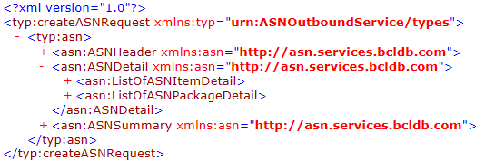

In the tables below:

* Shaded rows indicate sections of data
* A quoted value in the Description column represents a static value
* (1..N) Indicates the structure may repeat one or more times

### Header

One instance per ASN

|  |  |
| --- | --- |
| **XML Element** | **Description** |
| ASNHeader\ASNNumber | Unique ASN ID |
| ASNHeader\ASNIssueDate | Date ASN was created |
| ASNHeader\ASNOrderNumber | **Order Numbers (1..N)** |
| ASNHeader\ASNOrderNumber\BuyerOrderNumber | **Order number** |
| ASNHeader\ASNOrderNumber\SellerOrderNumber | Order number |
| ASNHeader\ShippingReferences |  |
| ASNHeader\ShippingReferences\BillOfLadingNumber\RefNum | **BOL number** |
| ASNHeader\ASNPurpose |  |
| ASNHeader\ASNPurpose\ASNPurposeCoded | “Original”[1] |
| ASNHeader\ASNDates | **Dates** |
| ASNHeader\ASNDates\ShipDate | **Ship date** |
| ASNHeader\ASNDates\DeliveryDate | **Expected Delivery date[2]** (if available) |
| ASNHeader\ASNParty | **Parties (3)** |
| ASNHeader\ASNParty\BuyerParty\ | **Ship To (Buyer)** |
| ASNHeader\ASNParty\BuyerParty\PartyID\Ident | Customer License Number |
| ASNHeader\ASNParty\BuyerParty\NameAddress\Name1 | Ship to name |
| ASNHeader\ASNParty\BuyerParty\NameAddress\Street | Ship to address |
| ASNHeader\ASNParty\BuyerParty\NameAddress\City | Ship to city |
| ASNHeader\ASNParty\BuyerParty\NameAddress\Region\RegionCoded | Ship to province {“BC”} |
| ASNHeader\ASNParty\BuyerParty\NameAddress\PostalCode | Ship to postal code |
| ASNHeader\ASNParty\BuyerParty\NameAddress\Country\CountryCoded | “CA” |
| ASNHeader\ASNParty\SellerParty\ | **Ship From (Seller)** |
| ASNHeader\ASNParty\SellerParty\PartyID\Ident | “RDC” |
| ASNHeader\ASNParty\SellerParty\NameAddress\Name1 | Ship from name |
| ASNHeader\ASNParty\SellerParty\NameAddress\Street | Ship from address |
| ASNHeader\ASNParty\SellerParty\NameAddress\City | Ship from city |
| ASNHeader\ASNParty\SellerParty\NameAddress\Region\RegionCoded | Ship from province {“BC”} |
| ASNHeader\ASNParty\SellerParty\NameAddress\PostalCode | Ship from postal code |
| ASNHeader\ASNParty\SellerParty\NameAddress\Country\CountryCoded | “CA” |
| ASNHeader\ASNParty\SellerParty\PrimaryContact\ | **Shipper Contact** |
| ASNHeader\ASNParty\SellerParty\PrimaryContact\ContactID\Ident\ | “RDC” |
| ASNHeader\ASNParty\SellerParty\PrimaryContact\ContactName | Shipper **contact name** |
| ASNHeader\ASNParty\SellerParty\PrimaryContact\ListOfContactNumber  \ContactNumber\ContactNumbervalue | Shipper **contact phone** |
| ASNHeader\ASNParty\CarrierParty\ | **Carrier** |
| ASNHeader\ASNParty\ CarrierParty \PartyID\Ident | Carrier ID[3]  One of:  “SPEEDEE”  “3SIXTY”  “PRCCA” - Purolator |
| ASNHeader\ASNParty\CarrierParty\NameAddress\Name1 | **Carrier Name** |

### Item list

ASNItemDetail repeats once per item inside ASNDetail\ASNItemDetail. Image below illustrates example of repeating item.

Structure

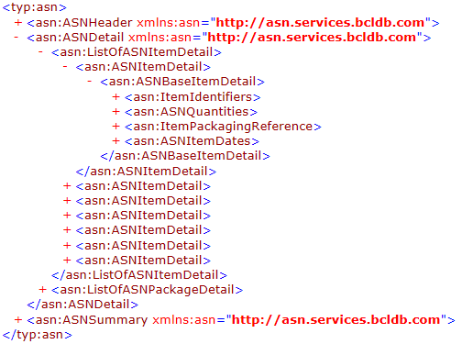

Fields

|  |  |
| --- | --- |
| **XML Element** | **Description** |
| ASNDetail\ListOfASNItemDetail\ASNItemDetail\ASNBaseItemDetail\ItemIdentifiers | **Item Identifiers** |
| ASNDetail\ListOfASNItemDetail\ASNItemDetail\ASNBaseItemDetail\ItemIdentifiers  \PartNumbers\SellerPartNumber\PartID | BC Cannabis Wholesale’s Item Number (**SKU**) |
| ASNDetail\ListOfASNItemDetail\ASNItemDetail\ASNBaseItemDetail\ItemIdentifiers  \PartNumbers\OtherIdentifiers\OtherIdentifiersCoded\ProductIdentifier   * **If** “**LotNumber**” = ASNDetail\ListOfASNItemDetail\ASNItemDetail\ASNBaseItemDetail   \ItemIdentifiers\PartNumbers\OtherIdentifiers\OtherIdentifiersCoded  \ProductIdentifierQualifierCoded | **Lot Number** (if available)  Product Barcode AI 10 |
| ASNDetail\ListOfASNItemDetail\ASNItemDetail\ASNBaseItemDetail\ItemIdentifiers  \PartNumbers\OtherIdentifiers\OtherIdentifiersCoded\ProductIdentifier   * **If** “**GTIN**” = ASNDetail\ListOfASNItemDetail\ASNItemDetail\ASNBaseItemDetail   \ItemIdentifiers\PartNumbers\OtherIdentifiers\OtherIdentifiersCoded  \ProductIdentifierQualifierCoded | **GTIN** for the item, at the sold unit level (if available).  Product Barcode AI 01 |
| ASNDetail\ListOfASNItemDetail\ASNItemDetail\ASNBaseItemDetail\ItemIdentifiers  \PartNumbers\OtherIdentifiers\OtherIdentifiersCoded\ProductIdentifier   * **If** “**UPC**” = ASNDetail\ListOfASNItemDetail\ASNItemDetail\ASNBaseItemDetail   \ItemIdentifiers\PartNumbers\OtherIdentifiers\OtherIdentifiersCoded  \ProductIdentifierQualifierCoded | **UPC** for the item, at the sold unit level, if available. |
| ASNDetail\ListOfASNItemDetail\ASNItemDetail\ASNBaseItemDetail\ItemIdentifiers  \ItemDescription | Item **Description** |
| ASNDetail\ListOfASNItemDetail\ASNItemDetail\ASNBaseItemDetail\ASNQuantities | **Quantities** |
| ASNDetail\ListOfASNItemDetail\ASNItemDetail\ASNBaseItemDetail\ASNQuantities  \OrderedQuantity\QuantityValue | Quantity **Ordered** |
| ASNDetail\ListOfASNItemDetail\ASNItemDetail\ASNBaseItemDetail\ASNQuantities  \OrderedQuantity\UnitOfMeasure | Quantity Ordered UOM |
| ASNDetail\ListOfASNItemDetail\ASNItemDetail\ASNBaseItemDetail\ASNQuantities  \ShippedQuanity\QuantityValue | Quantity **Shipped** |
| ASNDetail\ListOfASNItemDetail\ASNItemDetail\ASNBaseItemDetail\ASNQuantities  \ShippedQuantity\UnitOfMeasure | Quantity Shipped UOM |
| ASNDetail\ListOfASNItemDetail\ASNItemDetail\ASNBaseItemDetail  \ItemPackagingReference\PackageReference | **Package Reference** |
| ASNDetail\ListOfASNItemDetail\ASNItemDetail\ASNBaseItemDetail  \ItemPackagingReference\PackageReference\PackageIDReference | **Package Identifier**; the ID of the package in which this item is packed. Links to: ASNDetail\ListOfASNPackageDetail\ListOfPackage\Package\PackageID |
| ASNDetail\ListOfASNItemDetail\ASNItemDetail\ASNBaseItemDetail\ASNItemDates | **Item Dates** |
| ASNDetail\ListOfASNItemDetail\ASNItemDetail\ASNBaseItemDetail\ASNItemDates  \ListOfDateCoded\DateCoded\Date   * IF “ExpiryDate” = ASNDetail\ListOfASNItemDetail\ASNItemDetail   \ASNBaseItemDetail\ASNItemDates\ListOfDateCoded\DateCoded  \DateQualifier\DateQualifierCoded | **Expiry Date[4]**  Product Barcode AI 10 |

### Container list

Structure

ASNPackageDetail repeats one or more times.

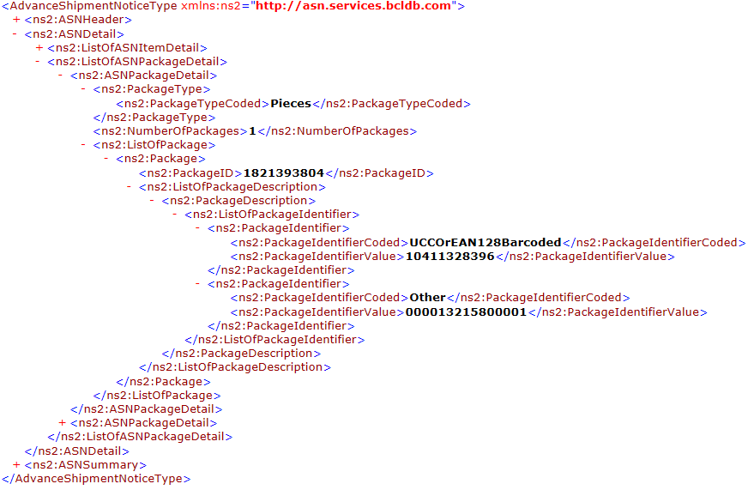

Fields

|  |  |
| --- | --- |
| **XML Element** | **Description** |
| ASNDetail\ListOfASNPackageDetail\PackageType\PackageTypeCoded | Currently always “**Pieces**”. May refer to a case or a pallet. |
| ASNDetail\ListOfASNPackageDetail\NumberOfPackages | Number of packages |
| ASNDetail\ListOfASNPackageDetail\ListOfPackage\ | (1..N) |
| ASNDetail\ListOfASNPackageDetail\ListOfPackage\Package\PackageID | **Package identifier**  *Links to PackageIDReference at the item level.* |
| ASNDetail\ListOfASNPackageDetail\ListOfPackage\Package  \ListOfPackageDescription\PackageDescription\ListOfPackageIdentifier  \PackageIdentifier\PackageIdentifier\PackageIdentifierValue   * If “**UCCOrEAN128Barcoded**” = ASNDetail\ListOfASNPackageDetail\ListOfPackage\Package   \ListOfPackageDescription\PackageDescription\ListOfPackageIdentifier  \PackageIdentifier\PackageIdentifier\PackageIdentifierCoded | Matches **SSCC** barcode on shipping container label, if available.  *This is reserved for future use.* |
| ASNDetail\ListOfASNPackageDetail\ListOfPackage\Package  \ListOfPackageDescription\PackageDescription\ListOfPackageIdentifier  \PackageIdentifier\PackageIdentifier\PackageIdentifierValue   * If “**Other**” = ASNDetail\ListOfASNPackageDetail\ListOfPackage\Package   \ListOfPackageDescription\PackageDescription\ListOfPackageIdentifier  \PackageIdentifier\PackageIdentifier\PackageIdentifierCoded | Matches **Tracking Number** barcode on shipping container label.  *See* *Shipping Lables* *below* |

### ASN summary

|  |  |
| --- | --- |
| **XML Element** | **Description** |
| ASNSummary\TranportPackagingTotals\TotalPackages | **Piece Count** |
| ASNSummary\TranportPackagingTotals\TotalGrossWeight\MeasurementValue | Shipment **weight** |
| ASNSummary\TranportPackagingTotals\TotalGrossWeight\UnitOfMeasure | Shipment weight UOM |

# Data File Delivery

ASNs will be available for download from BC Cannabis Wholesale’s sFTP website after a shipment is sent.

Access to or use of the BC Cannabis Wholesale sFTP service is restricted to those authorized by the BC Liquor Distribution Branch. Usage is monitored and violators may be prosecuted. All messages and   
data on this system are government records. Users are expected to comply with all LDB information policies.

An email will be sent to the customer’s primary email address on file with BC Cannabis Wholesale whenever a new ASN is available. This email will not show the full path to the new ASN. The message will provide a link to the site from which the document can be retrieved. The email’s intent is to prompt the customer for a manual retrieval of the ASN.

An automated script can be developed by the customer to regularly check for and download new ASN files. If this is done, the script must delete any files downloaded successfully to avoid processing the same file again the next time their system connects to the server. The sFTP site will retain a copy of the ASN in an archive folder accessible by the customer for a period of 3 months unless the customer deletes the file at an earlier time.

|  |  |  |
| --- | --- | --- |
| Site URL | Filetransfer.bccannabiswholesale.com | |
| Port | 22 | |
| Credentials | The customer’s standard username and password for BC Cannabis Wholesale | |
| Protocol | sFTP | |
| Folder Structure | \LN45… | One folder per license associated with account |
| \Archive | Contains archive folders |
| \PDF | Copies of human readable ASNs |
| \XML | Copies of XML ASNs |
| \XML | New XML ASNs |
| \PDF | New human readable ASNs |
| File Name | ASN<ASNNumber>_<timestamp>.XML | |

The customer will need to download the public key from the sFTP server and install it on the computer from which the automated download script is executed. This can be done by connecting to the site with a standard sFTP client application.

## Email notice

The image below illustrates an example of the email notice sent when a new ASN is available for download. The sender, subject, and content of this email is subject to change.

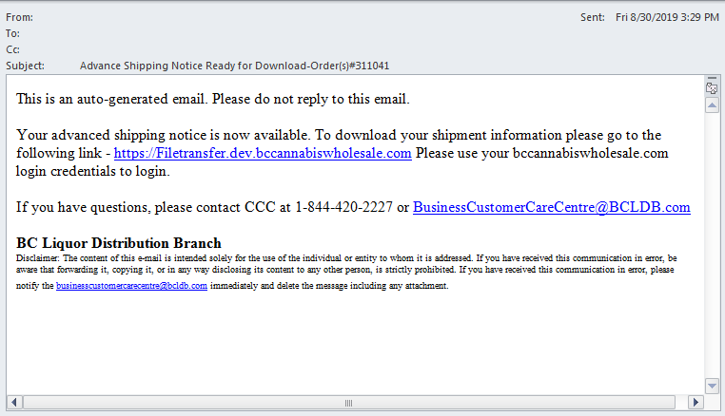

# Shipping Labels

The Tracking Number on each shipping unit is referenced in the ASN data, allowing for easy identification of packages and contents. The Tracking Number is found

Shipping units and label formats vary between parcel carriers and LTLs.

For parcel carriers, such as purolators, a shipping unit is case. Each case has a unique tracking number.

For LTLs a shipping unit is a pallet. Each pallet has a unique tracking number. A pallet will consist of multiple cases without individual tracking numbers.

Examples are shown on the pages below.

## Parcel Carrier

|  |  |
| --- | --- |
| Shipping Label | Context |
|  |  |

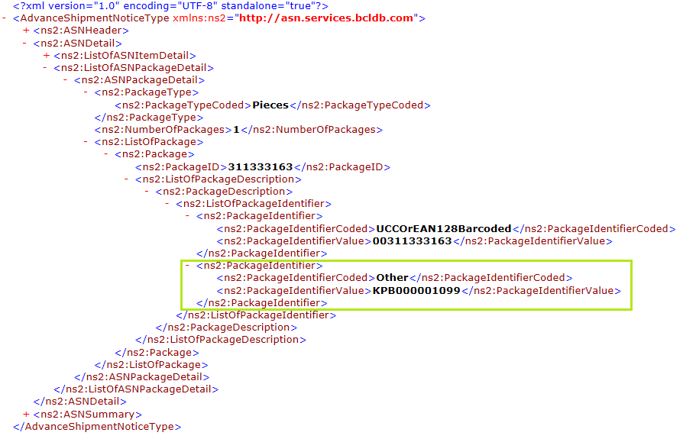

## LTL

|  |  |
| --- | --- |
| Shipping Label | Context |
|  |  |

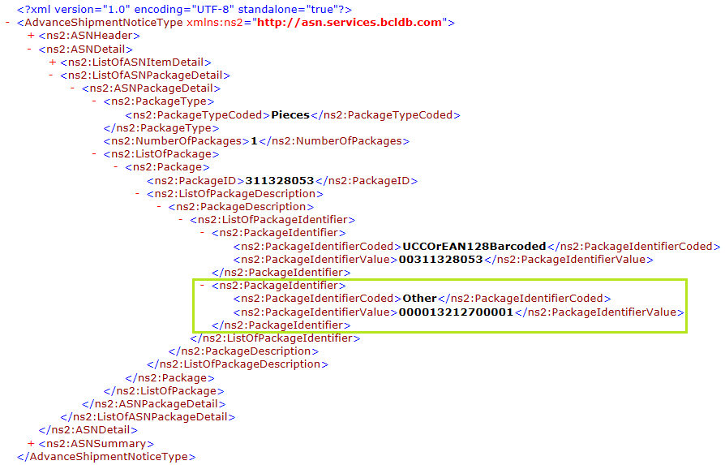

# Product Barcodes

The product barcoded is not directly referenced in the ASN. However, the individual components comprising the values of the product barcode are sent in the ASN.

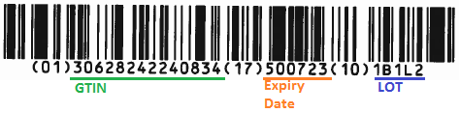

The value encoded in the product barcode consists of multiple fields. Each field is identified by a preceeding *application identified* (AI) enclosed in parentheses, in the printed barcode value below the barcode. The AI is followed by the field value.

Currently, the following fields are encoded. Each is shown below with its corresponding source in the ASN.

|  |  |  |
| --- | --- | --- |
| Field Name | AI | ASN Source Field |
| GTIN | **01** | ASNDetail\ListOfASNItemDetail\ASNItemDetail\ASNBaseItemDetail\ItemIdentifiers  \PartNumbers\OtherIdentifiers\OtherIdentifiersCoded\ProductIdentifier   * **If** “**GTIN**” = ASNDetail\ListOfASNItemDetail\ASNItemDetail\ASNBaseItemDetail   \ItemIdentifiers\PartNumbers\OtherIdentifiers\OtherIdentifiersCoded  \ProductIdentifierQualifierCoded |
| Expiry Date | **17** | ASNDetail\ListOfASNItemDetail\ASNItemDetail\ASNBaseItemDetail\ASNItemDates  \ListOfDateCoded\DateCoded\Date   * IF “ExpiryDate” = ASNDetail\ListOfASNItemDetail\ASNItemDetail   \ASNBaseItemDetail\ASNItemDates\ListOfDateCoded\DateCoded  \DateQualifier\DateQualifierCoded |
| Lot | **10** | ASNDetail\ListOfASNItemDetail\ASNItemDetail\ASNBaseItemDetail\ItemIdentifiers  \PartNumbers\OtherIdentifiers\OtherIdentifiersCoded\ProductIdentifier   * **If** “**LotNumber**” = ASNDetail\ListOfASNItemDetail\ASNItemDetail\ASNBaseItemDetail   \ItemIdentifiers\PartNumbers\OtherIdentifiers\OtherIdentifiersCoded  \ProductIdentifierQualifierCoded |

1. Only original ASNs are issued at this time. There are no updates to or cancellations of ASN documents.
2. The time component of the delivery date should be ignored. This field does not represent an appointment time, but an expected delivery date.
3. The list of carriers may change over time.
4. This is a date-time field. Only the date portion of the data is relevant.